

**Slide 1 Bad points**

__________________________________________________________________________________

**Slide 2 Bad points**

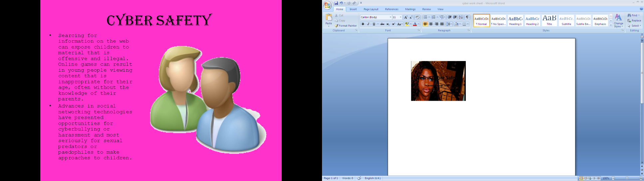

__________________________________________________________________________________



**Slide 3 Bad points**

__________________________________________________________________________________



**Slide 4 Bad points**

__________________________________________________________________________________



**Slide 5 Bad points**

__________________________________________________________________________________



**Slide 6 Bad points**

__________________________________________________________________________________